2024-04-27 02:28:02.622630: I tensorflow/core/platform/cpu_feature_guard.cc:182] This TensorFlow binary is optimized to use available CPU instructions in performance-critical operations.

To enable the following instructions: SSE SSE2 SSE3 SSE4.1 SSE4.2 AVX AVX2 FMA, in other operations, rebuild TensorFlow with the appropriate compiler flags.

Epoch 1/15

2024-04-27 02:28:05.266354: W tensorflow/tsl/framework/cpu_allocator_impl.cc:83] Allocation of 2080374784 exceeds 10% of free system memory.

2024-04-27 02:28:06.742181: W tensorflow/tsl/framework/cpu_allocator_impl.cc:83] Allocation of 2080374784 exceeds 10% of free system memory.

2024-04-27 02:28:06.897266: W tensorflow/tsl/framework/cpu_allocator_impl.cc:83] Allocation of 2080374784 exceeds 10% of free system memory.

2024-04-27 02:28:07.869621: W tensorflow/tsl/framework/cpu_allocator_impl.cc:83] Allocation of 2080374784 exceeds 10% of free system memory.

2024-04-27 02:28:08.000407: W tensorflow/tsl/framework/cpu_allocator_impl.cc:83] Allocation of 2080374784 exceeds 10% of free system memory.

1682/1682 [==============================] - 18847s 11s/step - loss: 3.7665 - accuracy: 0.6483 - val_loss: 1.5411 - val_accuracy: 0.6722 - lr: 5.0000e-05

Epoch 2/15

1682/1682 [==============================] - 18869s 11s/step - loss: 0.9441 - accuracy: 0.7205 - val_loss: 0.7067 - val_accuracy: 0.6792 - lr: 5.0000e-05

Epoch 3/15

1682/1682 [==============================] - 20584s 12s/step - loss: 0.5327 - accuracy: 0.7760 - val_loss: 0.5806 - val_accuracy: 0.6704 - lr: 5.0000e-05

Epoch 4/15

1682/1682 [==============================] - 19918s 12s/step - loss: 0.4030 - accuracy: 0.8377 - val_loss: 0.6338 - val_accuracy: 0.6731 - lr: 5.0000e-05

Epoch 5/15

1682/1682 [==============================] - 20428s 12s/step - loss: 0.3174 - accuracy: 0.8803 - val_loss: 0.7655 - val_accuracy: 0.6659 - lr: 5.0000e-05

Epoch 6/15

1682/1682 [==============================] - 19622s 12s/step - loss: 0.2228 - accuracy: 0.9204 - val_loss: 0.9381 - val_accuracy: 0.6580 - lr: 2.5000e-05

2883/2883 [==============================] - 1654s 573ms/step

Evaluation Metrics:

Precision: 0.6694

Recall: 0.6881

F1 Score: 0.6786

ROC AUC: 0.7994

PR AUC: 0.8276

MCC: 0.3484

y_pred = (test_scores > 0.6).astype(int)

...: y_true = y_test.astype(int)

...:

...: # Calculate evaluation metrics

...: precision = precision_score(y_true, y_pred)

...: recall = recall_score(y_true, y_pred)

...: f1 = f1_score(y_true, y_pred)

...: roc_auc = roc_auc_score(y_true, test_scores)

...: pr_auc = average_precision_score(y_true, test_scores)

...: mcc = matthews_corrcoef(y_true, y_pred)

...:

...: # Display evaluation metrics

...: print("\nEvaluation Metrics:")

...: print(f'Precision: {precision:.4f}')

...: print(f'Recall: {recall:.4f}')

...: print(f'F1 Score: {f1:.4f}')

...: print(f'ROC AUC: {roc_auc:.4f}')

...: print(f'PR AUC: {pr_auc:.4f}')

...: print(f'MCC: {mcc:.4f}')

Evaluation Metrics:

Precision: 0.8231

Recall: 0.5089

F1 Score: 0.6290

ROC AUC: 0.7994

PR AUC: 0.8276

MCC: 0.4323

In [15]: y_pred = (test_scores > 0.7).astype(int)

...: y_true = y_test.astype(int)

...:

...: # Calculate evaluation metrics

...: precision = precision_score(y_true, y_pred)

...: recall = recall_score(y_true, y_pred)

...: f1 = f1_score(y_true, y_pred)

...: roc_auc = roc_auc_score(y_true, test_scores)

...: pr_auc = average_precision_score(y_true, test_scores)

...: mcc = matthews_corrcoef(y_true, y_pred)

...:

...: # Display evaluation metrics

...: print("\nEvaluation Metrics:")

...: print(f'Precision: {precision:.4f}')

...: print(f'Recall: {recall:.4f}')

...: print(f'F1 Score: {f1:.4f}')

...: print(f'ROC AUC: {roc_auc:.4f}')

...: print(f'PR AUC: {pr_auc:.4f}')

...: print(f'MCC: {mcc:.4f}')

Evaluation Metrics:

Precision: 0.9036

Recall: 0.4805

F1 Score: 0.6274

ROC AUC: 0.7994

PR AUC: 0.8276

MCC: 0.4858

Epoch 1/15

2024-06-16 06:05:11.816709: W tensorflow/tsl/framework/cpu_allocator_impl.cc:83] Allocation of 2080374784 exceeds 10% of free system memory.

2024-06-16 06:05:13.223259: W tensorflow/tsl/framework/cpu_allocator_impl.cc:83] Allocation of 2080374784 exceeds 10% of free system memory.

2024-06-16 06:05:13.536355: W tensorflow/tsl/framework/cpu_allocator_impl.cc:83] Allocation of 2080374784 exceeds 10% of free system memory.

2024-06-16 06:05:14.887577: W tensorflow/tsl/framework/cpu_allocator_impl.cc:83] Allocation of 2080374784 exceeds 10% of free system memory.

2024-06-16 06:05:15.027045: W tensorflow/tsl/framework/cpu_allocator_impl.cc:83] Allocation of 2080374784 exceeds 10% of free system memory.

1682/1682 [==============================] - 20542s 12s/step - loss: 3.7827 - accuracy: 0.6499 - val_loss: 2.0800 - val_accuracy: 0.6284 - lr: 5.0000e-05

Epoch 2/15

1682/1682 [==============================] - 20112s 12s/step - loss: 0.9456 - accuracy: 0.7218 - val_loss: 0.7277 - val_accuracy: 0.6720 - lr: 5.0000e-05

Epoch 3/15

1682/1682 [==============================] - 21867s 13s/step - loss: 0.5313 - accuracy: 0.7749 - val_loss: 0.5856 - val_accuracy: 0.6788 - lr: 5.0000e-05

Epoch 4/15

1682/1682 [==============================] - 20682s 12s/step - loss: 0.4009 - accuracy: 0.8381 - val_loss: 0.6393 - val_accuracy: 0.6782 - lr: 5.0000e-05

Epoch 5/15

1682/1682 [==============================] - 21417s 13s/step - loss: 0.3154 - accuracy: 0.8817 - val_loss: 0.7863 - val_accuracy: 0.6708 - lr: 5.0000e-05

Epoch 6/15

1682/1682 [==============================] - 20135s 12s/step - loss: 0.2190 - accuracy: 0.9216 - val_loss: 0.9632 - val_accuracy: 0.6644 - lr: 2.5000e-05

2883/2883 [==============================] - 1134s 393ms/step

Additional Evaluation Metrics:

Precision: 0.6478

Recall: 0.7789

F1 Score: 0.7073

ROC AUC: 0.7998

PR AUC: 0.8267

MCC: 0.3630

y_pred = (test_scores > 0.6).astype(int)

...: y_true = y_test.astype(int)

...:

...: # Calculate additional evaluation metrics

...: precision = precision_score(y_true, y_pred)

...: recall = recall_score(y_true, y_pred)

...: f1 = f1_score(y_true, y_pred)

...: roc_auc = roc_auc_score(y_true, test_scores)

...: pr_auc = average_precision_score(y_true, test_scores)

...: mcc = matthews_corrcoef(y_true, y_pred)

...:

...: # Display evaluation metrics

...: print("\nAdditional Evaluation Metrics:")

...: print(f'Precision: {precision:.4f}')

...: print(f'Recall: {recall:.4f}')

...: print(f'F1 Score: {f1:.4f}')

...: print(f'ROC AUC: {roc_auc:.4f}')

...: print(f'PR AUC: {pr_auc:.4f}')

...: print(f'MCC: {mcc:.4f}')

...:

Additional Evaluation Metrics:

Precision: 0.7623

Recall: 0.5407

F1 Score: 0.6327

ROC AUC: 0.7998

PR AUC: 0.8267

MCC: 0.3889

In [6]: y_pred = (test_scores > 0.7).astype(int)

...: y_true = y_test.astype(int)

...:

...: # Calculate additional evaluation metrics

...: precision = precision_score(y_true, y_pred)

...: recall = recall_score(y_true, y_pred)

...: f1 = f1_score(y_true, y_pred)

...: roc_auc = roc_auc_score(y_true, test_scores)

...: pr_auc = average_precision_score(y_true, test_scores)

...: mcc = matthews_corrcoef(y_true, y_pred)

...:

...: # Display evaluation metrics

...: print("\nAdditional Evaluation Metrics:")

...: print(f'Precision: {precision:.4f}')

...: print(f'Recall: {recall:.4f}')

...: print(f'F1 Score: {f1:.4f}')

...: print(f'ROC AUC: {roc_auc:.4f}')

...: print(f'PR AUC: {pr_auc:.4f}')

...: print(f'MCC: {mcc:.4f}')

...:

Additional Evaluation Metrics:

Precision: 0.9032

Recall: 0.4820

F1 Score: 0.6285

ROC AUC: 0.7998

PR AUC: 0.8267

MCC: 0.4865

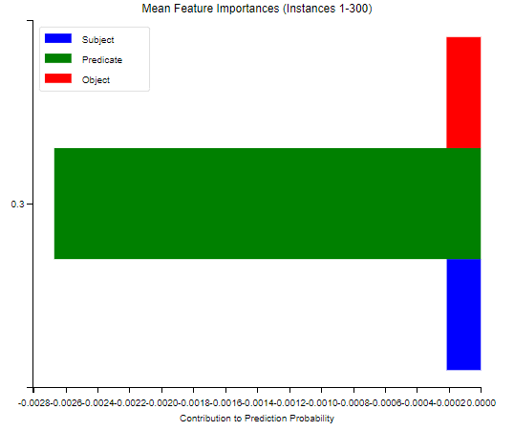

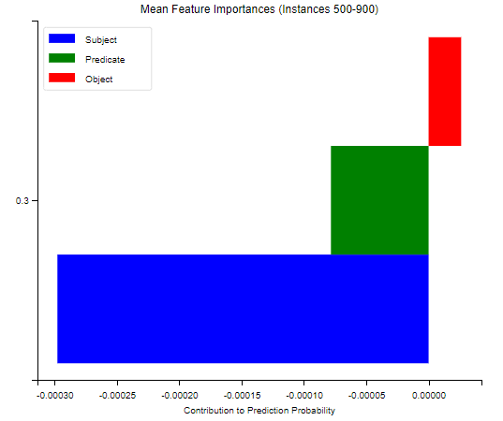

Εικόνα που περιέχει κείμενο, στιγμιότυπο οθόνης, οθόνη, πολυχρωμία

Περιγραφή που δημιουργήθηκε αυτόματα

Εικόνα που περιέχει κείμενο, διάγραμμα, γραμμή, γράφημα

Περιγραφή που δημιουργήθηκε αυτόματα

Εικόνα που περιέχει κείμενο, στιγμιότυπο οθόνης, διάγραμμα, ορθογώνιο παραλληλόγραμμο

Περιγραφή που δημιουργήθηκε αυτόματα

Εικόνα που περιέχει κείμενο, γράφημα, γραμμή, διάγραμμα

Περιγραφή που δημιουργήθηκε αυτόματα

Εικόνα που περιέχει κείμενο, διάγραμμα, γράφημα, γραμμή

Περιγραφή που δημιουργήθηκε αυτόματα

Triplet 1 (Original):

Subject: https://ec.europa.eu/eurostat/NLP4StatRef/knowledge/hlth_ehis_aw1u, Predicate: https://ec.europa.eu/eurostat/NLP4StatRef/ontology/term, Object: hlth_ehis_aw1u

157/157 [==============================] - 164s 1s/step

Intercept 0.3801982141642698

Prediction_local [0.16724483]

Right: 0.3194839

Feature Importances (Coefficients):

Object: -0.11667071816366932

Predicate: -0.08606015551612833

Subject: -0.01022251467552875

Triplet 2 (Original):

Subject: https://ec.europa.eu/eurostat/NLP4StatRef/ontology/ei_qna, Predicate: http://www.w3.org/1999/02/22-rdf-syntax-ns#type, Object: https://ec.europa.eu/eurostat/NLP4StatRef/ontology/StatisticalData

157/157 [==============================] - 148s 945ms/step

Intercept 0.08958352175127149

Prediction_local [0.66178244]

Right: 0.5773044

Feature Importances (Coefficients):

Predicate: 0.30978458955208016

Object: 0.25959895487150936

Subject: 0.0028153781253875167

Triplet 3 (Original):

Subject: https://ec.europa.eu/eurostat/NLP4StatRef/knowledge/paragraph9574_3455, Predicate: http://www.w3.org/1999/02/22-rdf-syntax-ns#type, Object: https://ec.europa.eu/eurostat/NLP4StatRef/ontology/Paragraph

157/157 [==============================] - 182s 1s/step

Intercept 0.20436617764912923

Prediction_local [0.4027267]

Right: 0.4508467

Feature Importances (Coefficients):

Predicate: 0.3368031606347875

Object: -0.13137643313561229

Subject: -0.007066206967113965

Triplet 4 (Original):

Subject: https://ec.europa.eu/eurostat/NLP4StatRef/ontology/fats_08, Predicate: https://ec.europa.eu/eurostat/NLP4StatRef/ontology/level, Object: 4

157/157 [==============================] - 149s 950ms/step

Intercept 0.393641887581467

Prediction_local [0.10827255]

Right: 0.026526159

Feature Importances (Coefficients):

Object: -0.19342135480528352

Predicate: -0.09063168539709014

Subject: -0.0013162958883439842

Triplet 5 (Original):

Subject: https://ec.europa.eu/eurostat/NLP4StatRef/knowledge/glossaryArticle118, Predicate: https://ec.europa.eu/eurostat/NLP4StatRef/ontology/hasReference, Object: https://ec.europa.eu/eurostat/NLP4StatRef/knowledge/referenceSource59

157/157 [==============================] - 167s 1s/step

Intercept 0.28850054019758026

Prediction_local [0.15067339]

Right: 0.013208363

Feature Importances (Coefficients):

Predicate: -0.4115618339456614

Object: 0.26631439349344727

Subject: 0.007420291641417589